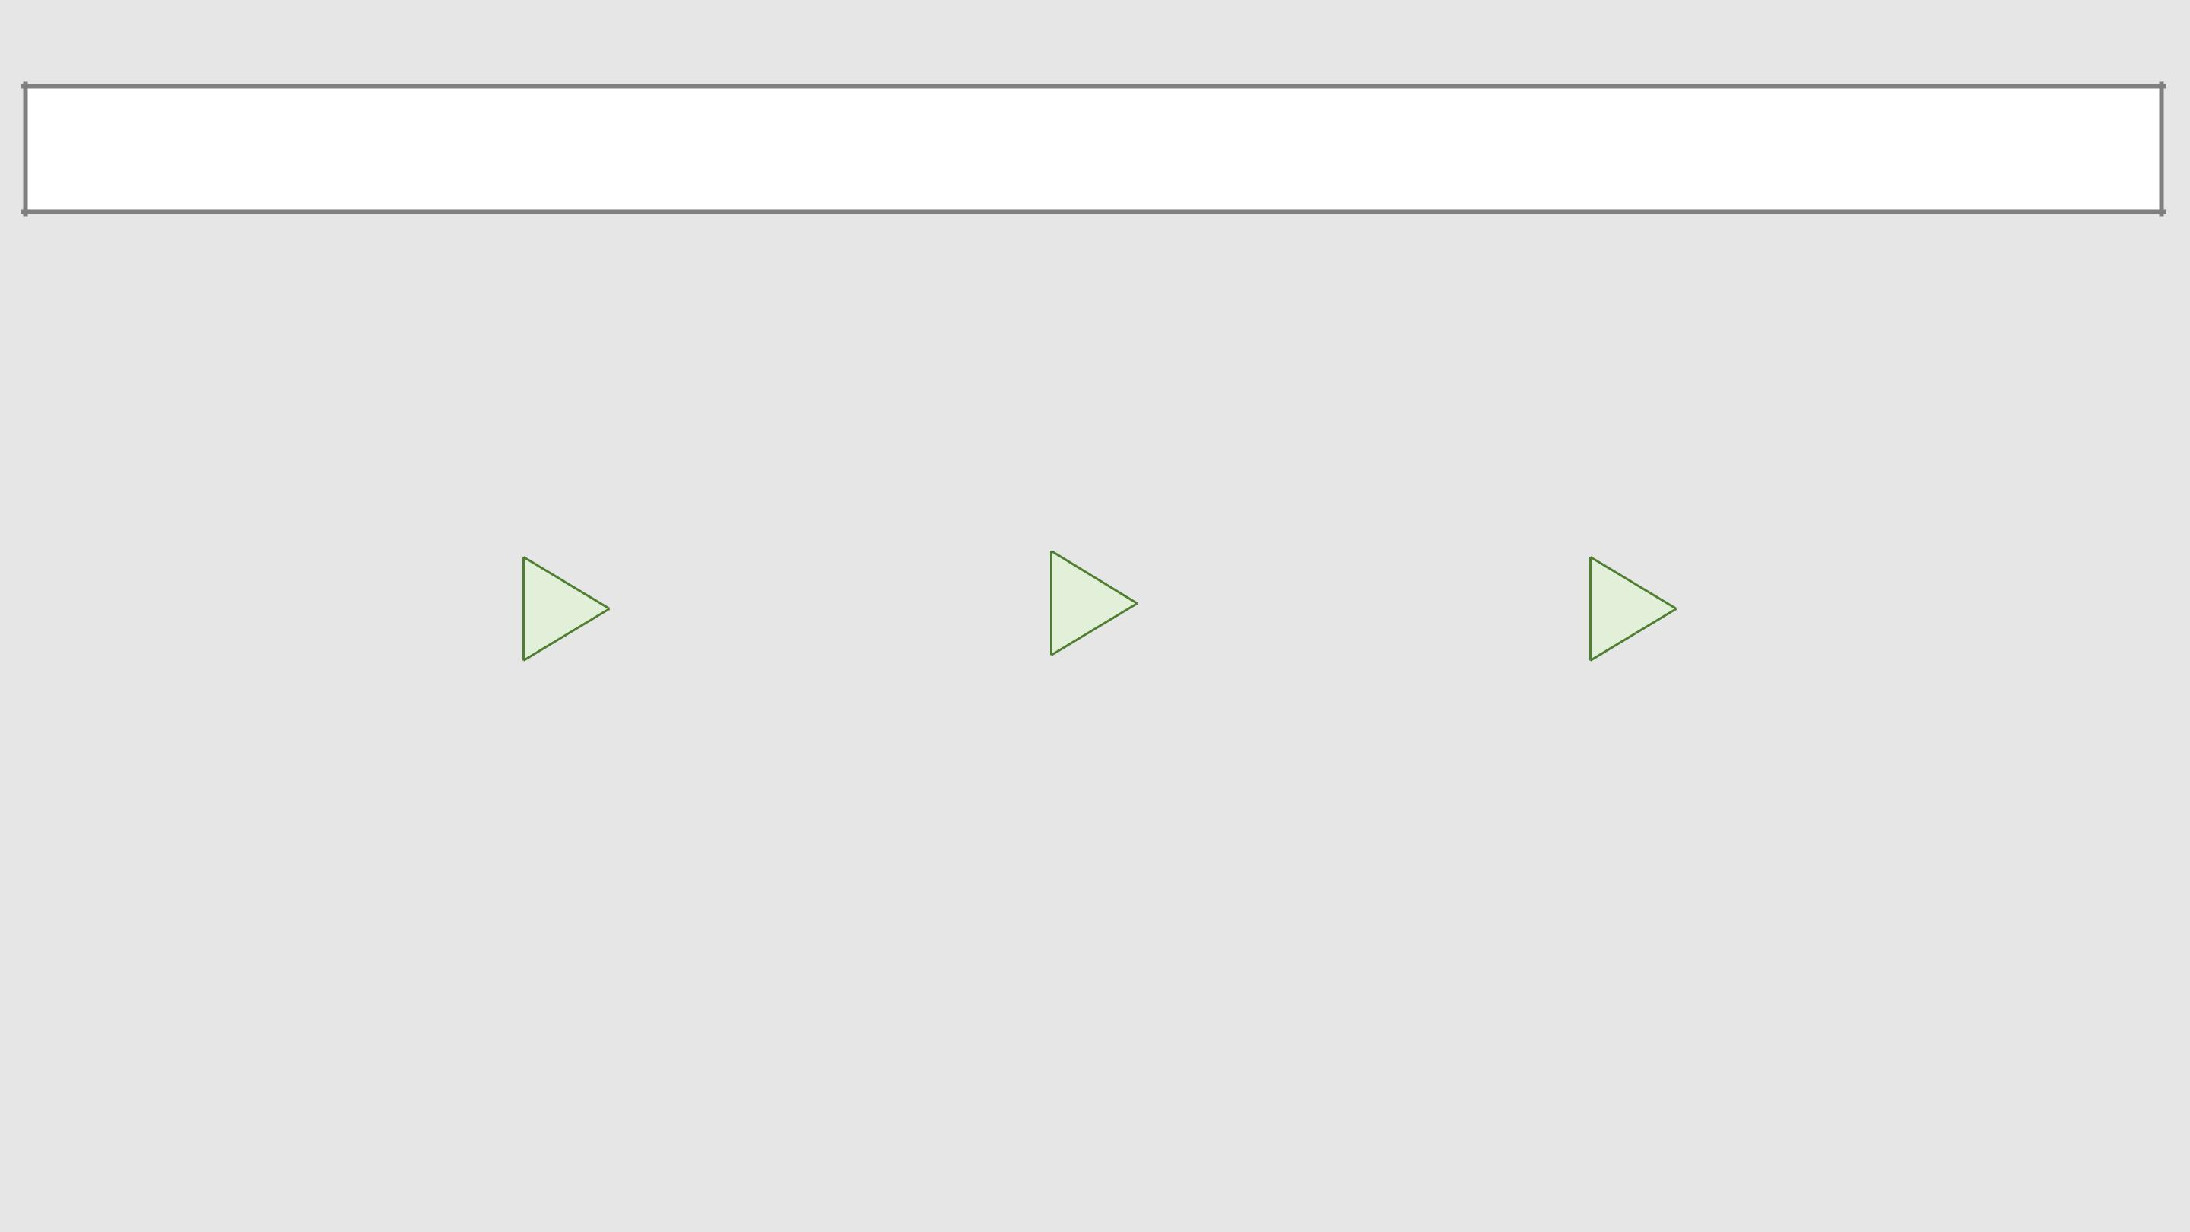  LOGIC MODEL TEMPLATE | DATE: |  | ITERATION #:

DESCRIPTION OF SOLUTION: What is the purpose/goal of the mHealth activity?

ACTIVITIES |  |  |  | OUTCOMES
ACTIVITIES |  | OUTPUTS |  | OUTCOMES |  | IMPACT
What are the main things the project will |  | What are the direct tangible products of |  | What are the results of your program? |  | What are the long-term results of your
do/provide? (Examples: events, trainings, |  | the activities? (Examples: # of trainings, # |  | (Examples: % change in behavior, |  | program? (Example: improved health
workshops, promotions, send messages, |  | of workshops, # of messages sent, |  | attitudes, awareness, skills, etc.) |  | outcomes)
collect data, etc.) |  | frequency of data collected, etc.)

